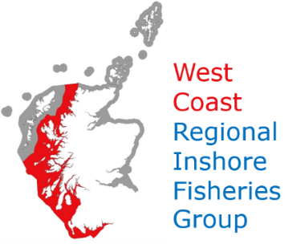
West Coast Regional Inshore Fisheries Group
Management Committee Meeting
Tuesday 10th November 10:30 on Zoom
Login Details: id: 854 8512 4527. Password: 074798
AGENDA
1/. Welcome-Introductions-apologies
2/. Minutes from previous meeting; 14th Jan 2020 Actions
3/. Marine Scotland Update; (Jim Watson, Stuart Bell)
4/. Fisheries and Exiting the EU.
5/. Bullfish Market (Michael MacCorquodale)
6/. Sub Group Updates:
I…..Solway;
II.....Clyde; Mull;
III…Mull;
IV…Proposed new Groups for the North West
6/. Work Group Updates:
I….Creels;
II…Scallops;
III.. Aquaculture
7/. Understanding the Consequences of Scallop Dredging in Relation to Seabed Habitat Types, Conservation Features and Other Industry Sectors. (Mairi Fenton)
8/. AOB; Date of next Meeting

